- Locate: use to find the location of the file
Sudo apt install m locate this will install the m locate
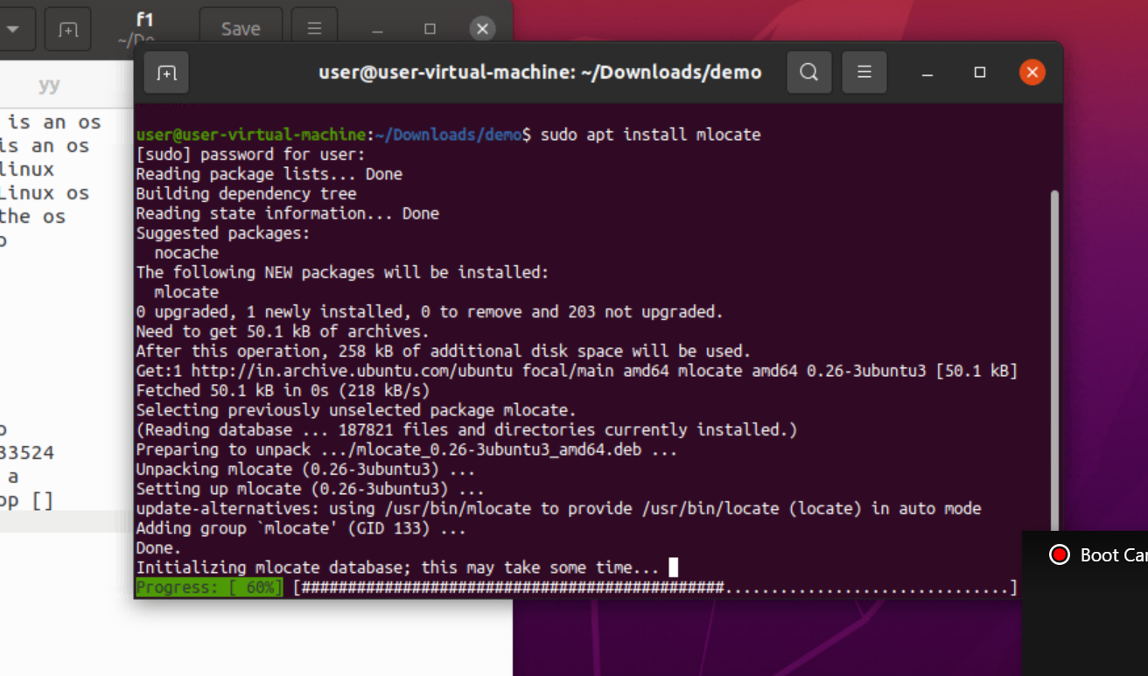

2. locate f1 : thi swill give the location of the f1 file
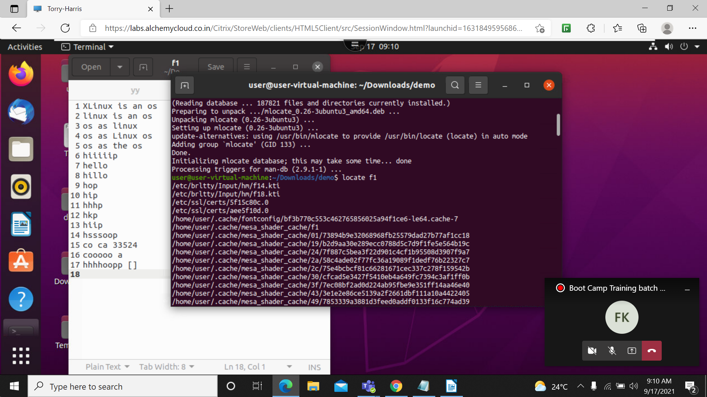

3. locate “.html” -n 10: this will 10 files which is ending with the html
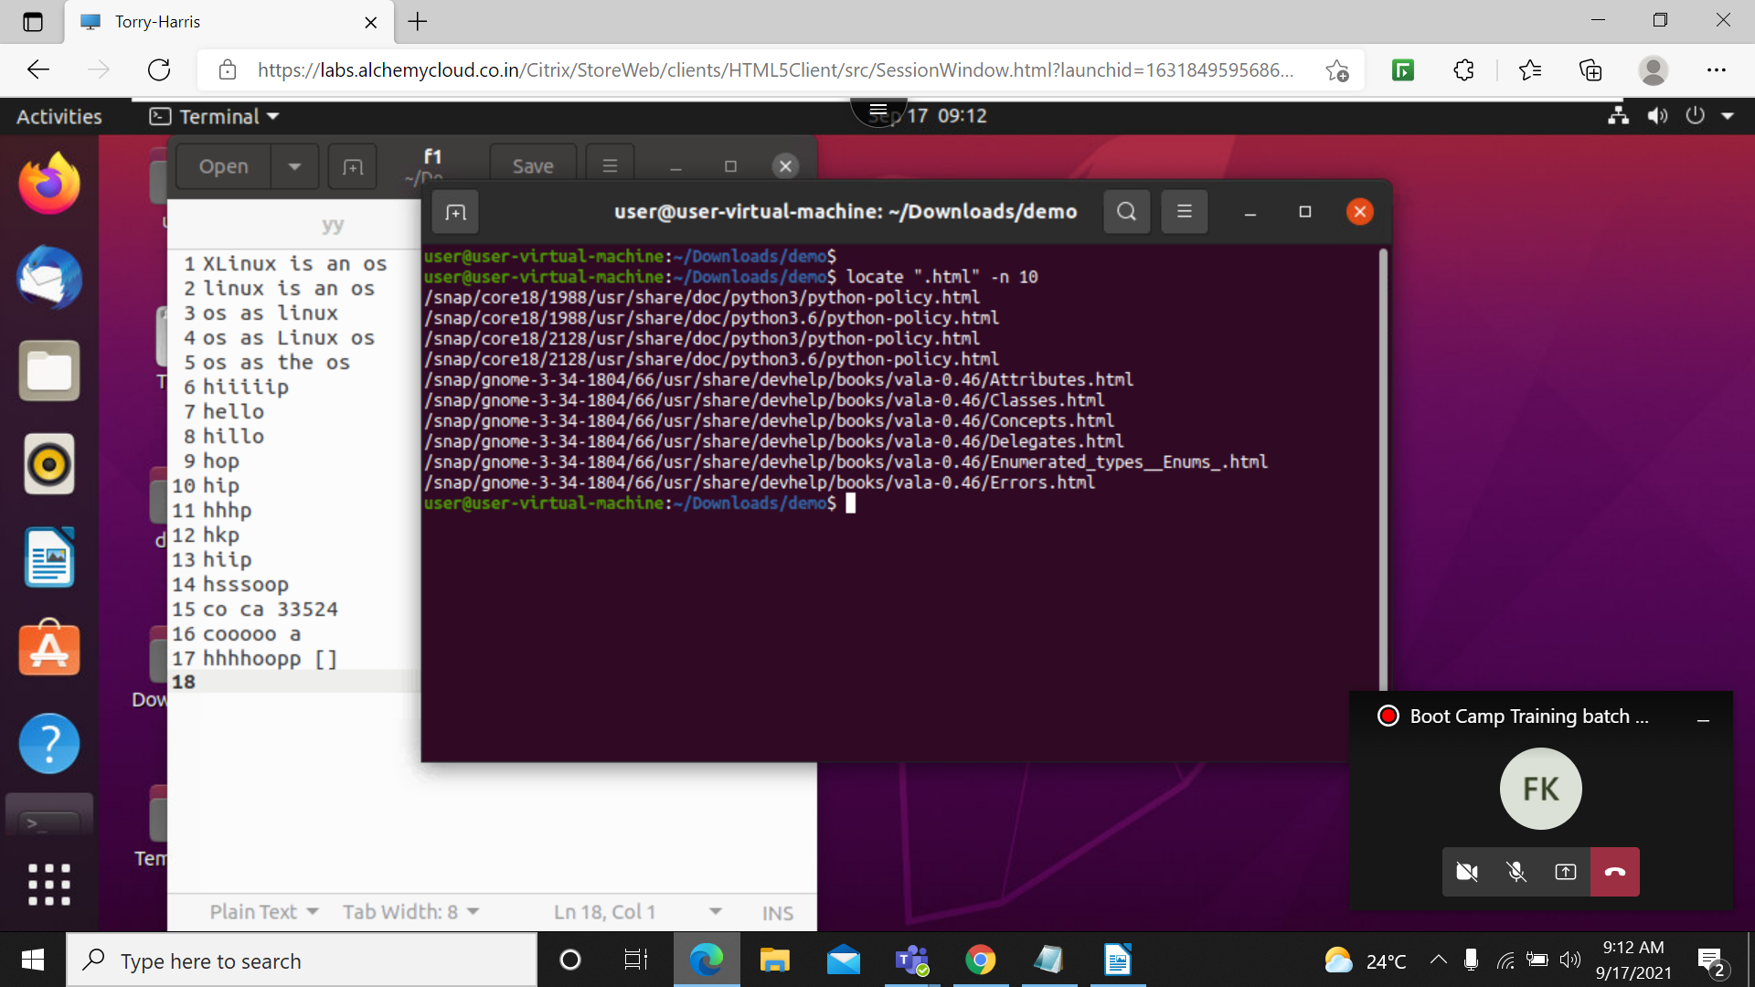

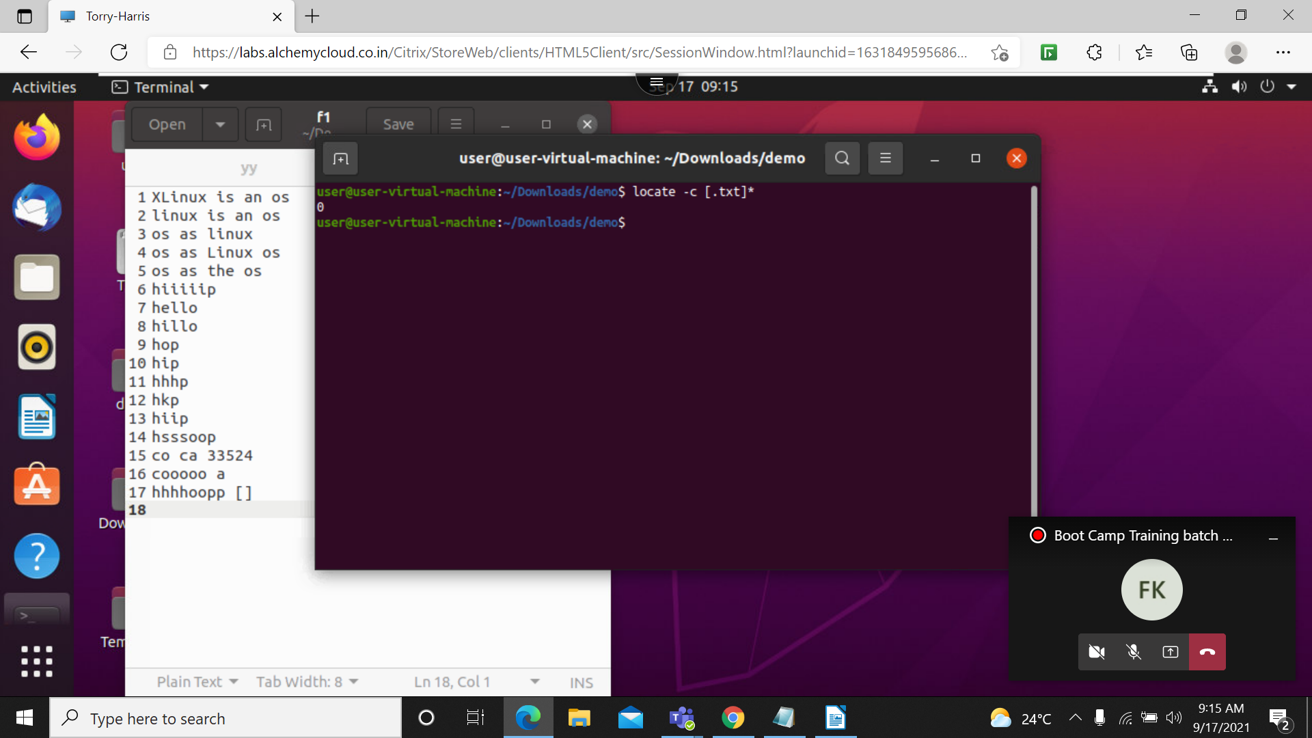
4. locate -c [.txt]*: this will count the files ending with txt

5. locate -i *f1.txt*
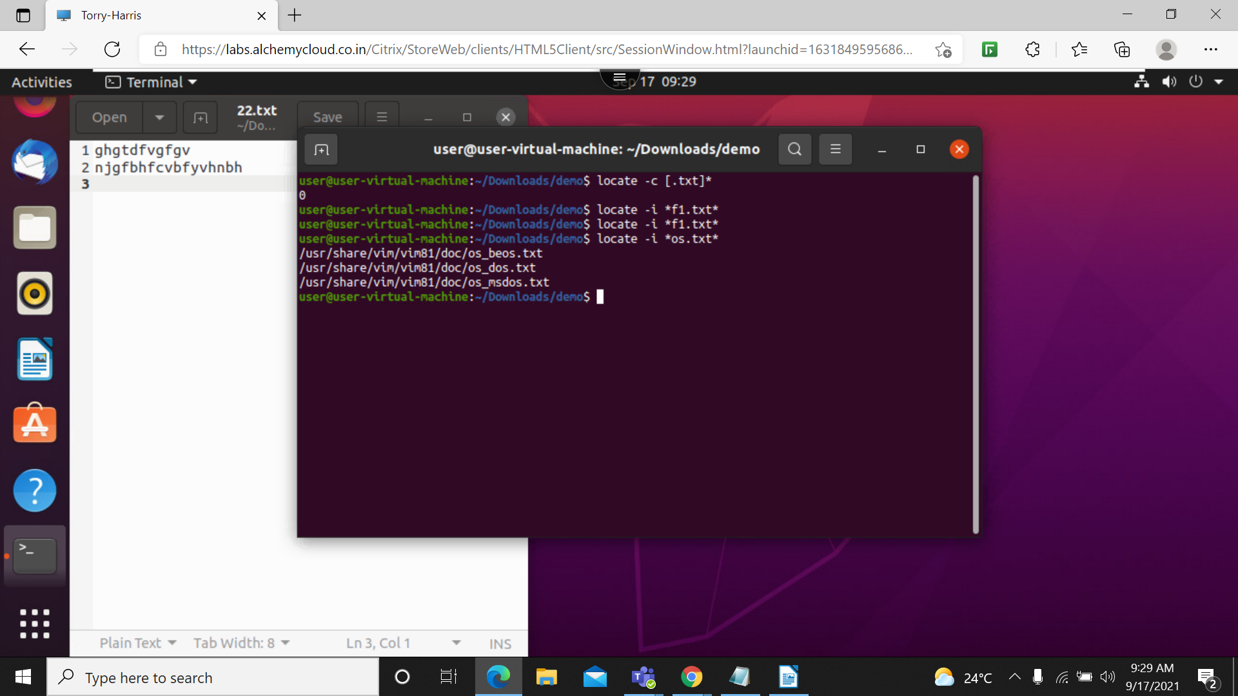
Ignore Case Sensitive Locate Outputs. This command is configured to process queries in a case sensitive manner. It means SAMPLE.TXT will show a different result than sample.txt.

6.ping: use to check the network connection between the server and host

bash shell
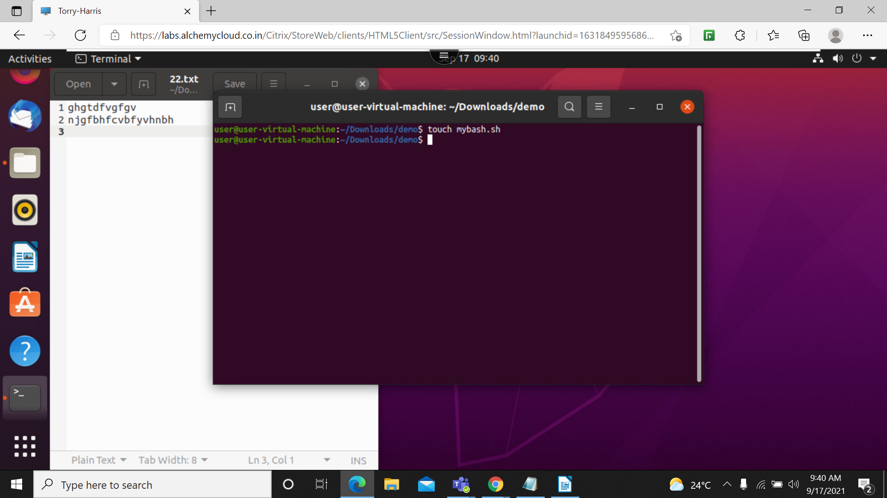
1. touch: use to craete a bash file r shell file

2. gedit a.sh: this use to creat a text file
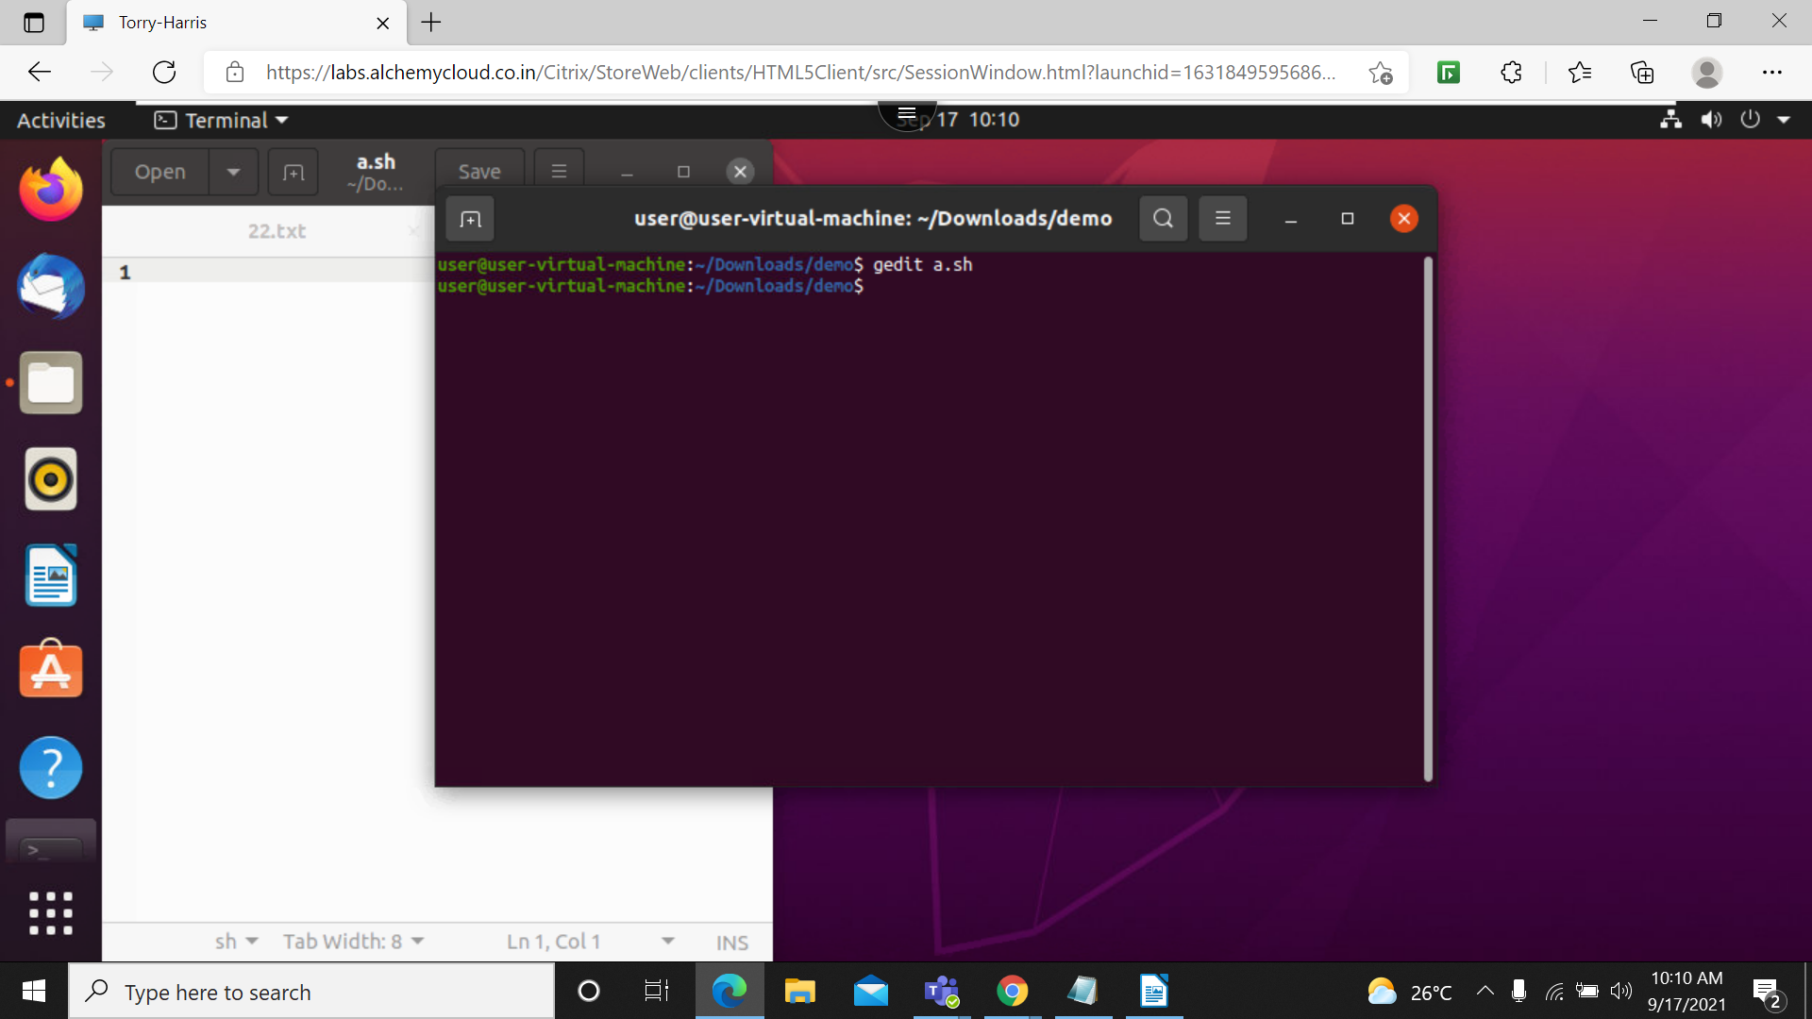

3. vim mybash1.sh: this use to write the txt in a mybash filee and save
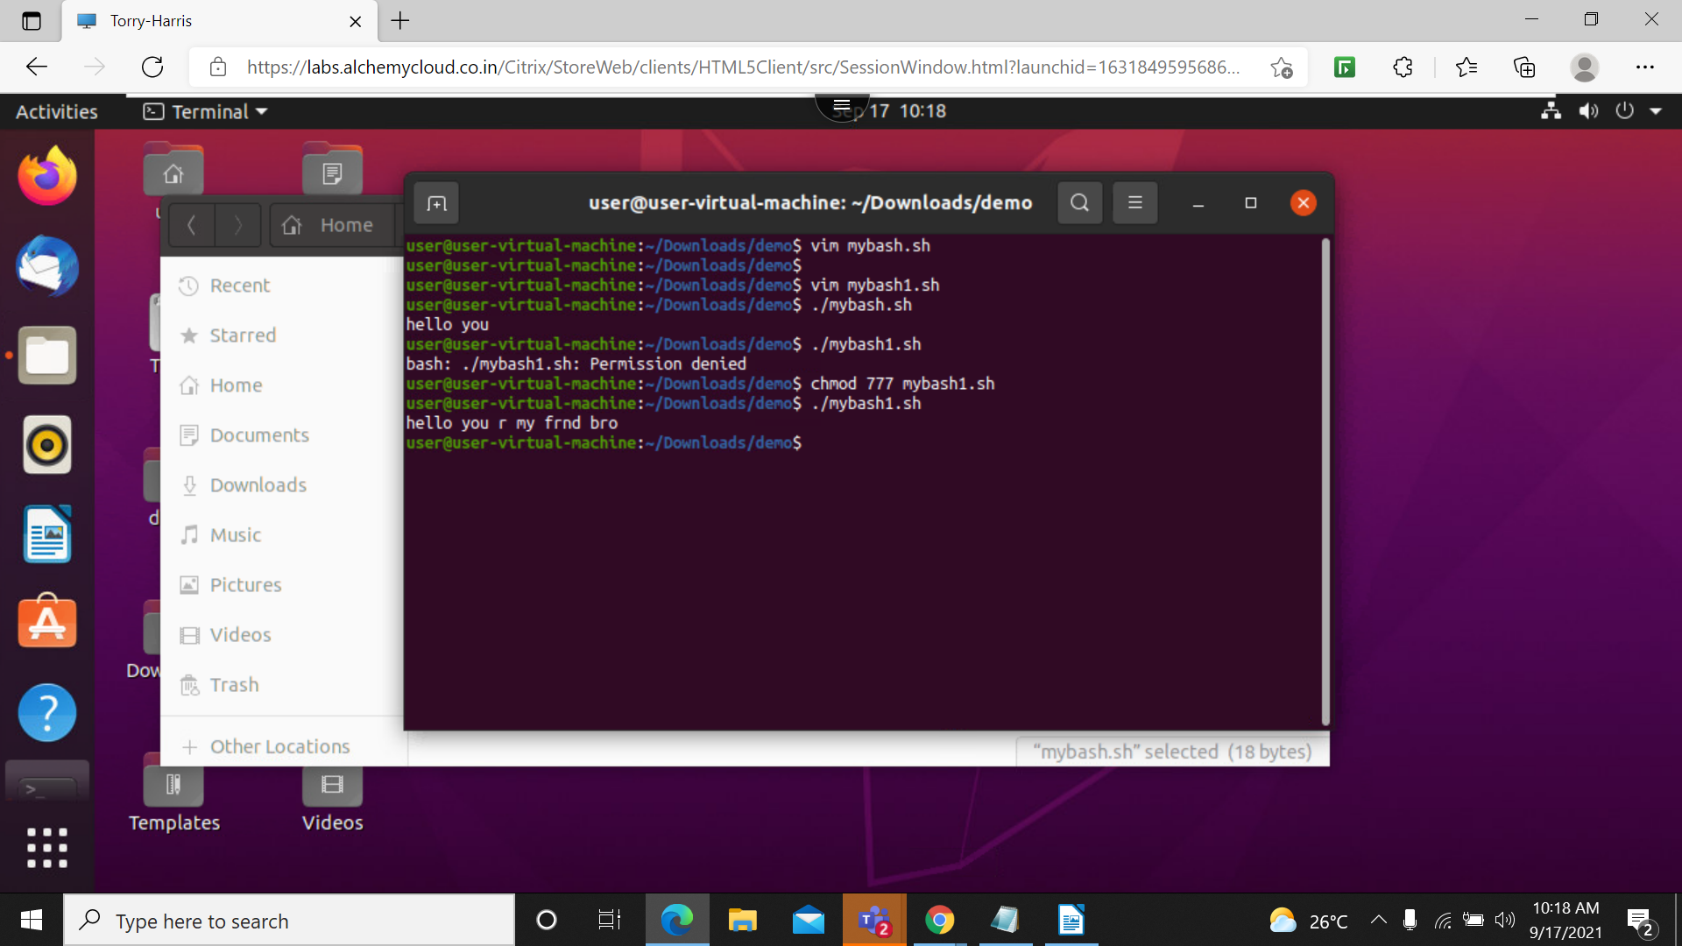
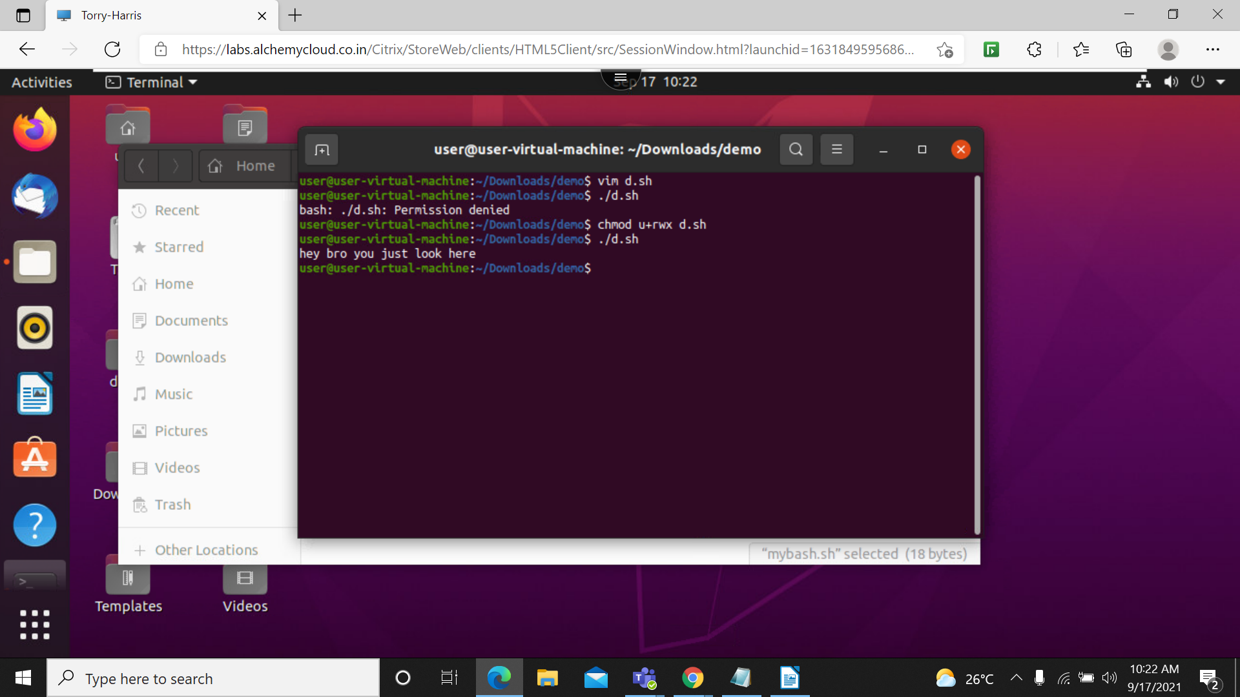

4. gedit file1.sh : this is created file and in this file I have created folders and give permission to tat and execute
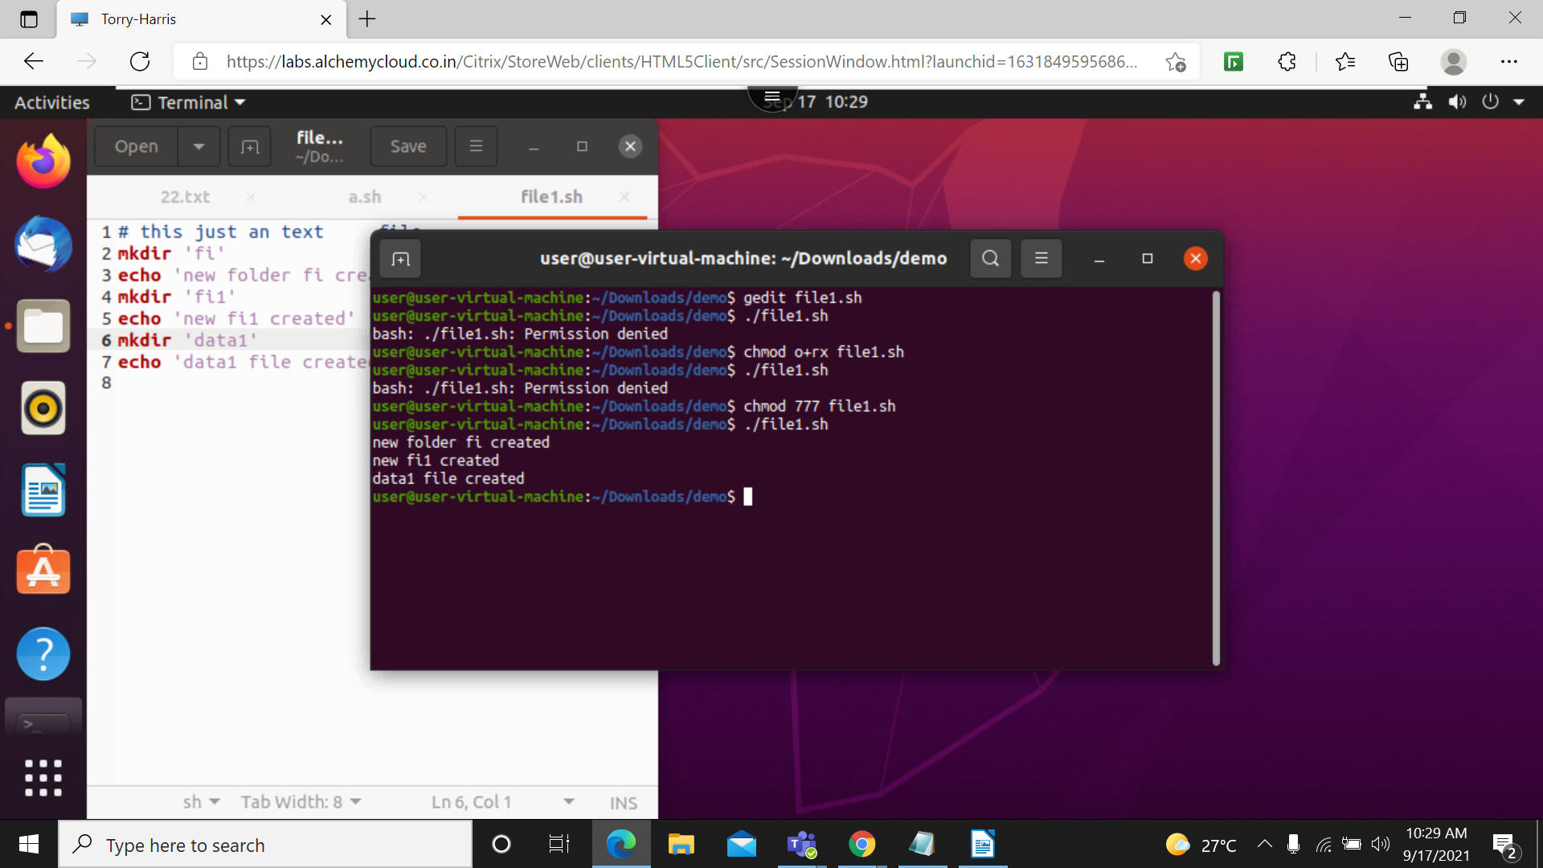

like loop we can create one more folder and remove the directory all together

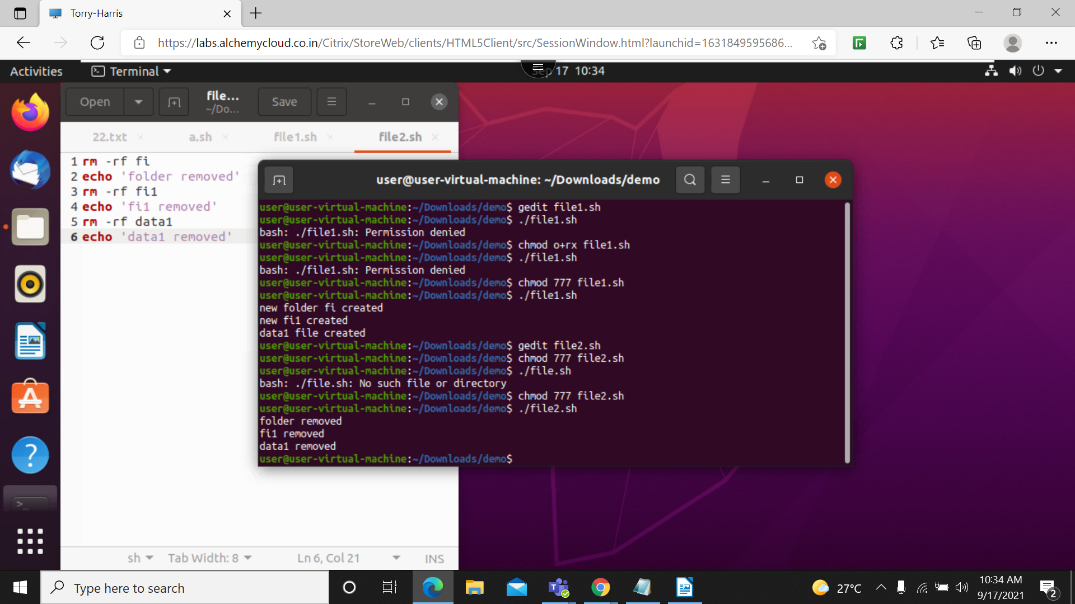

5. echo ‘hello’>w2.txt: this use to create file directly and add txt to that file
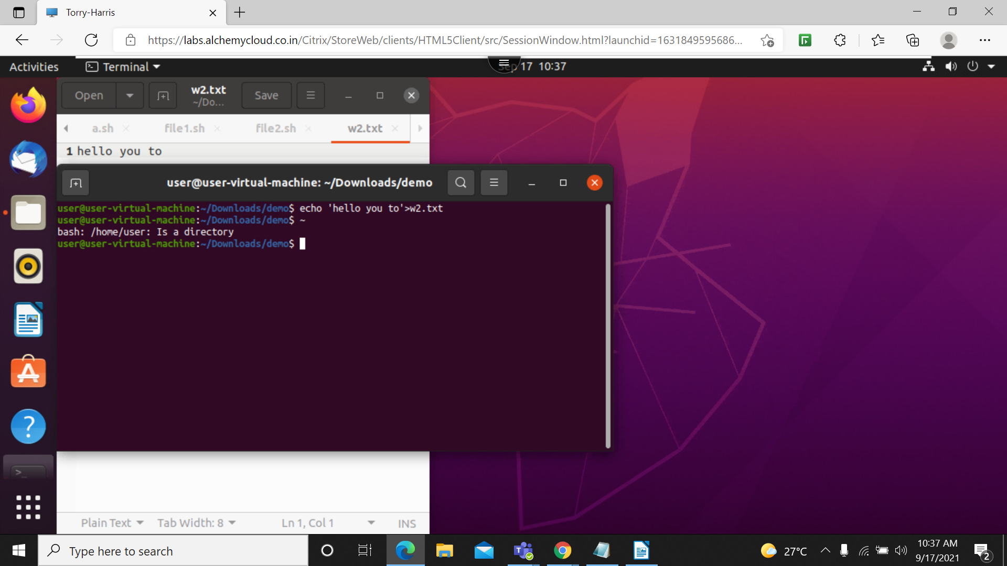

6. to make make all the text in one file we need to use after echo >>log.txt
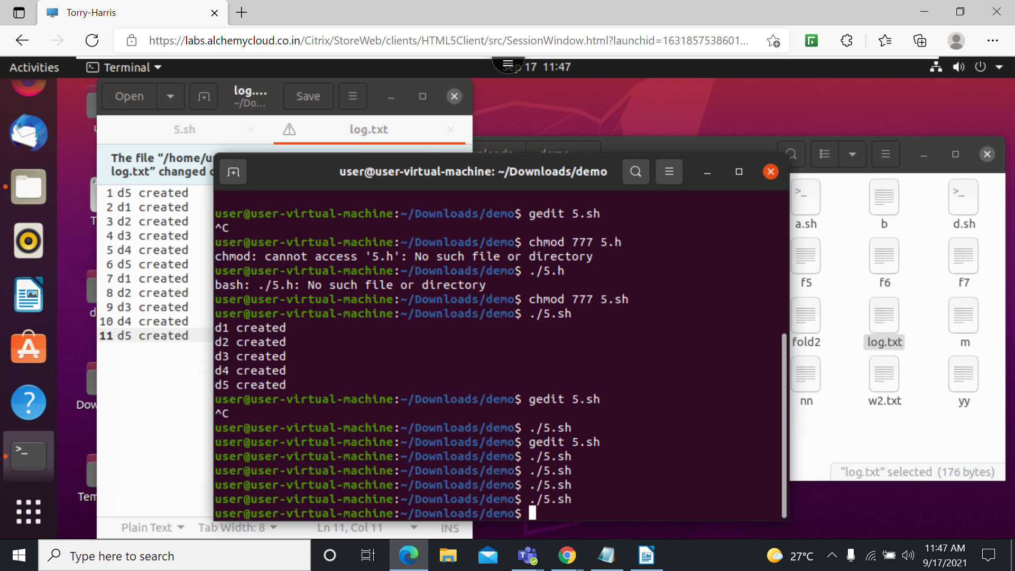

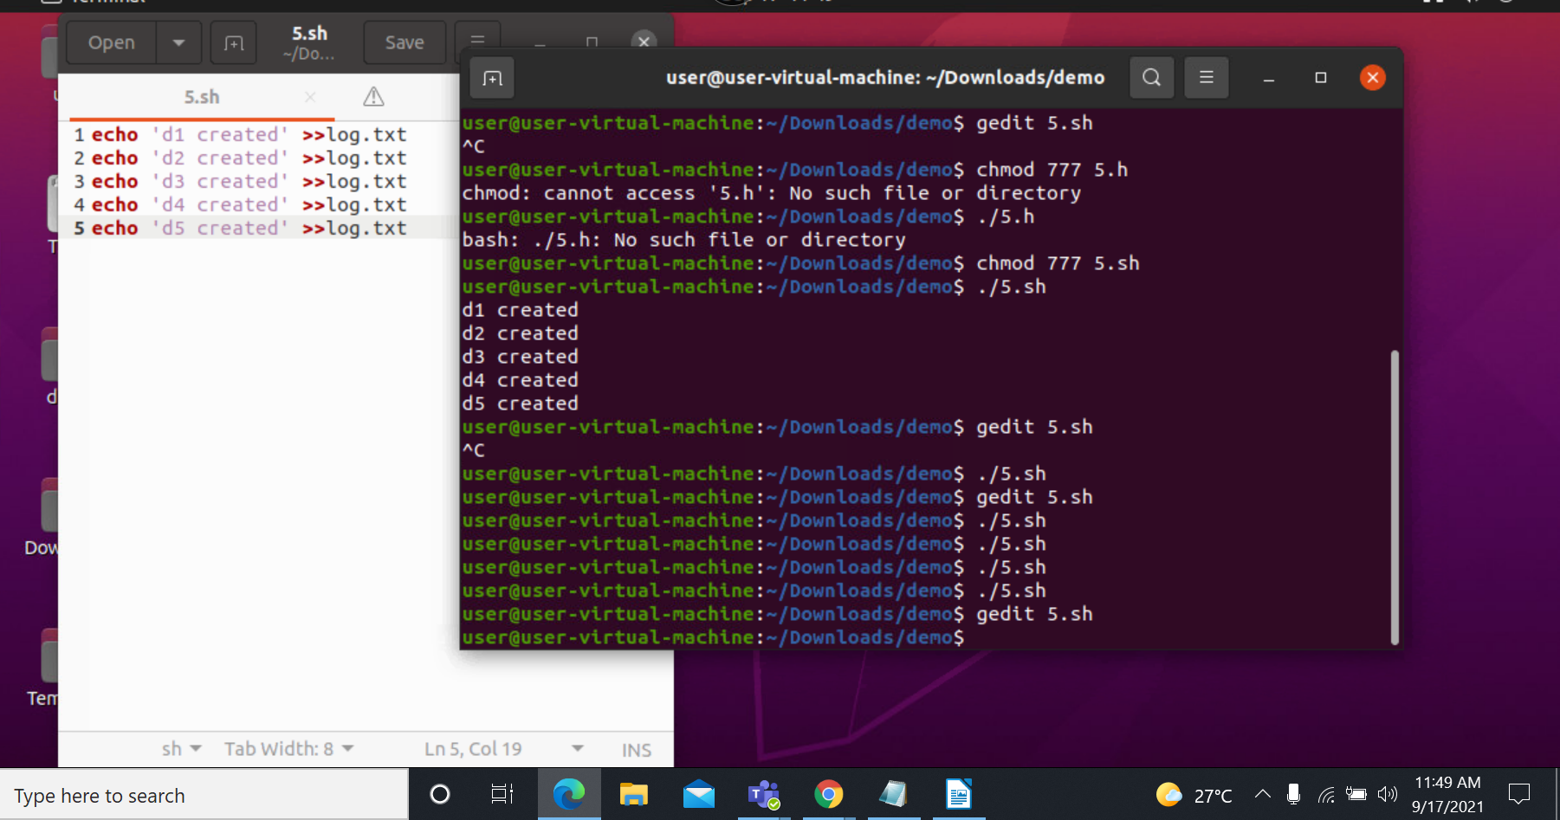

1. write a program to caluclate the simple intrest
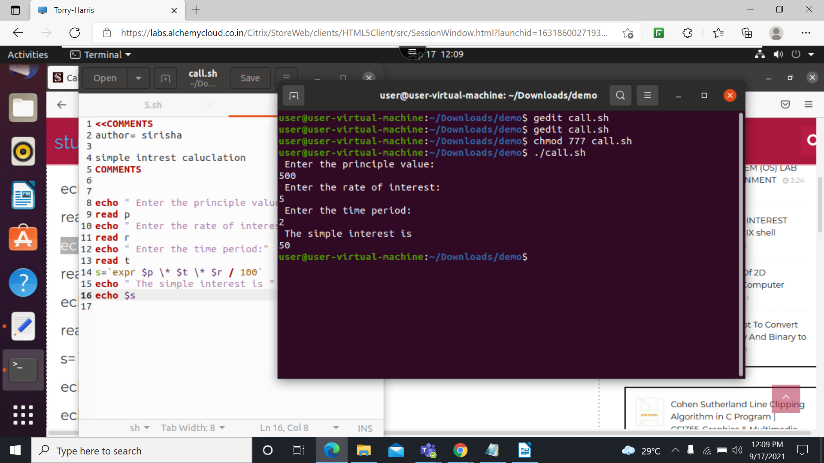

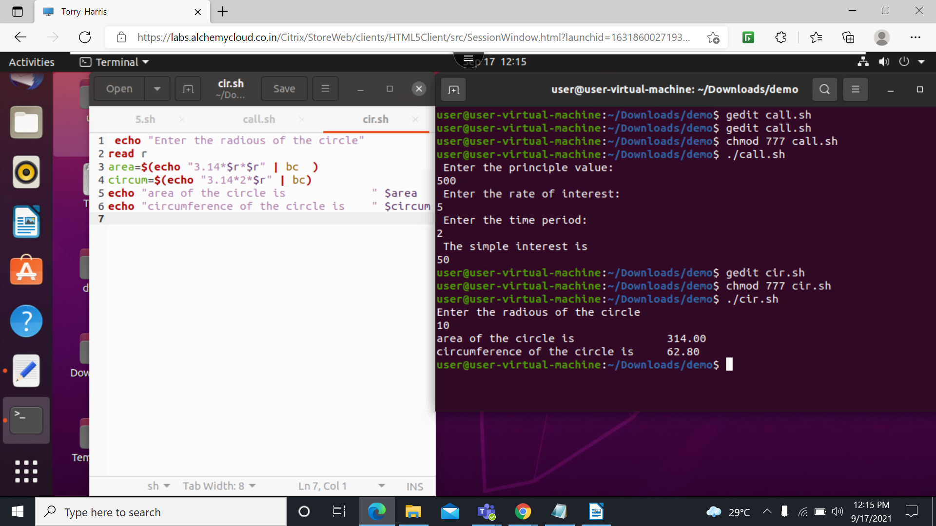
2. write a program to calculate the circumfrance of a circle

3. write a program to caluclate the diagnoal of a rectangle
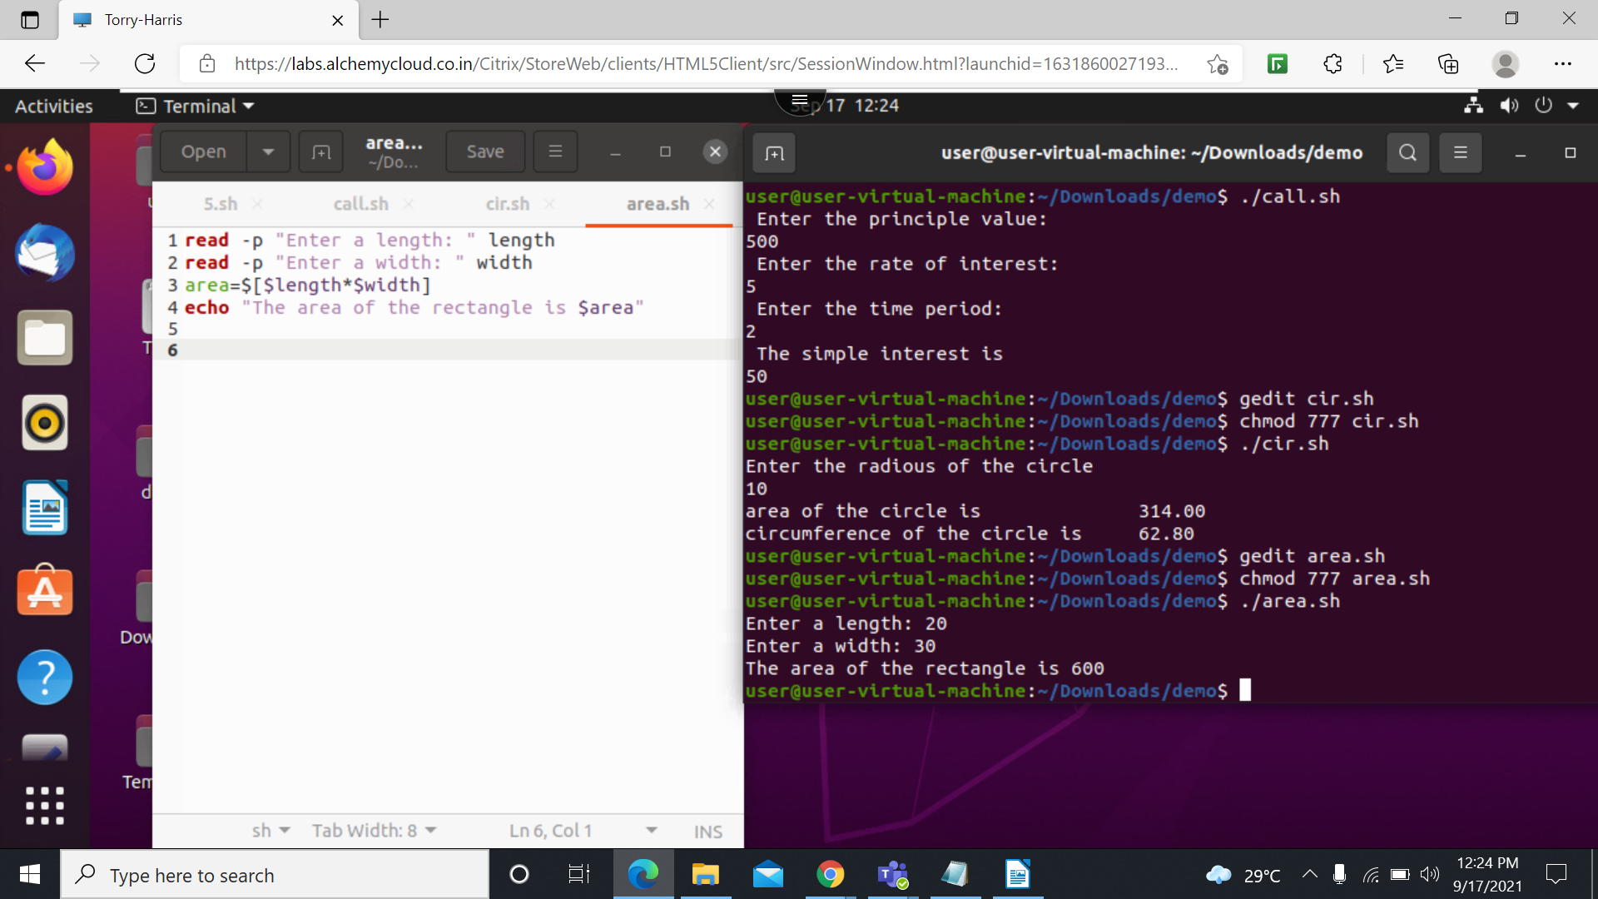

write a program to calculate the diagonal of rectangle
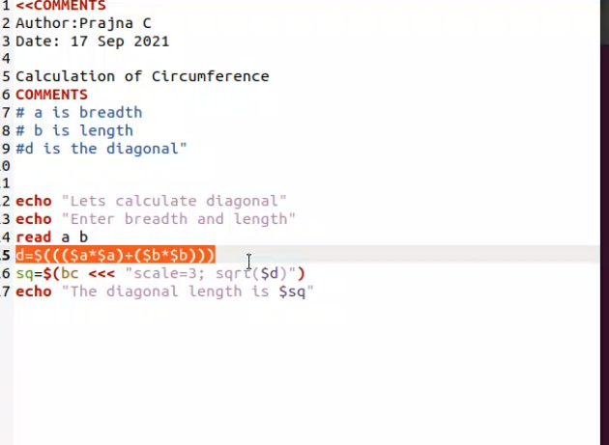

1. write a program to print
*
**
***
****
*****

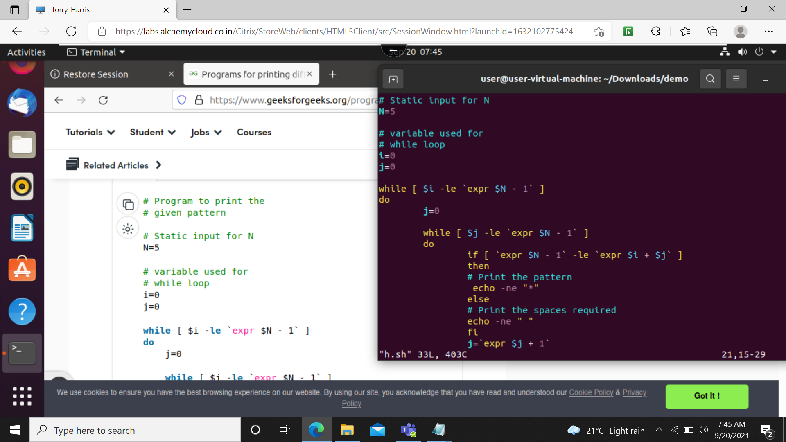
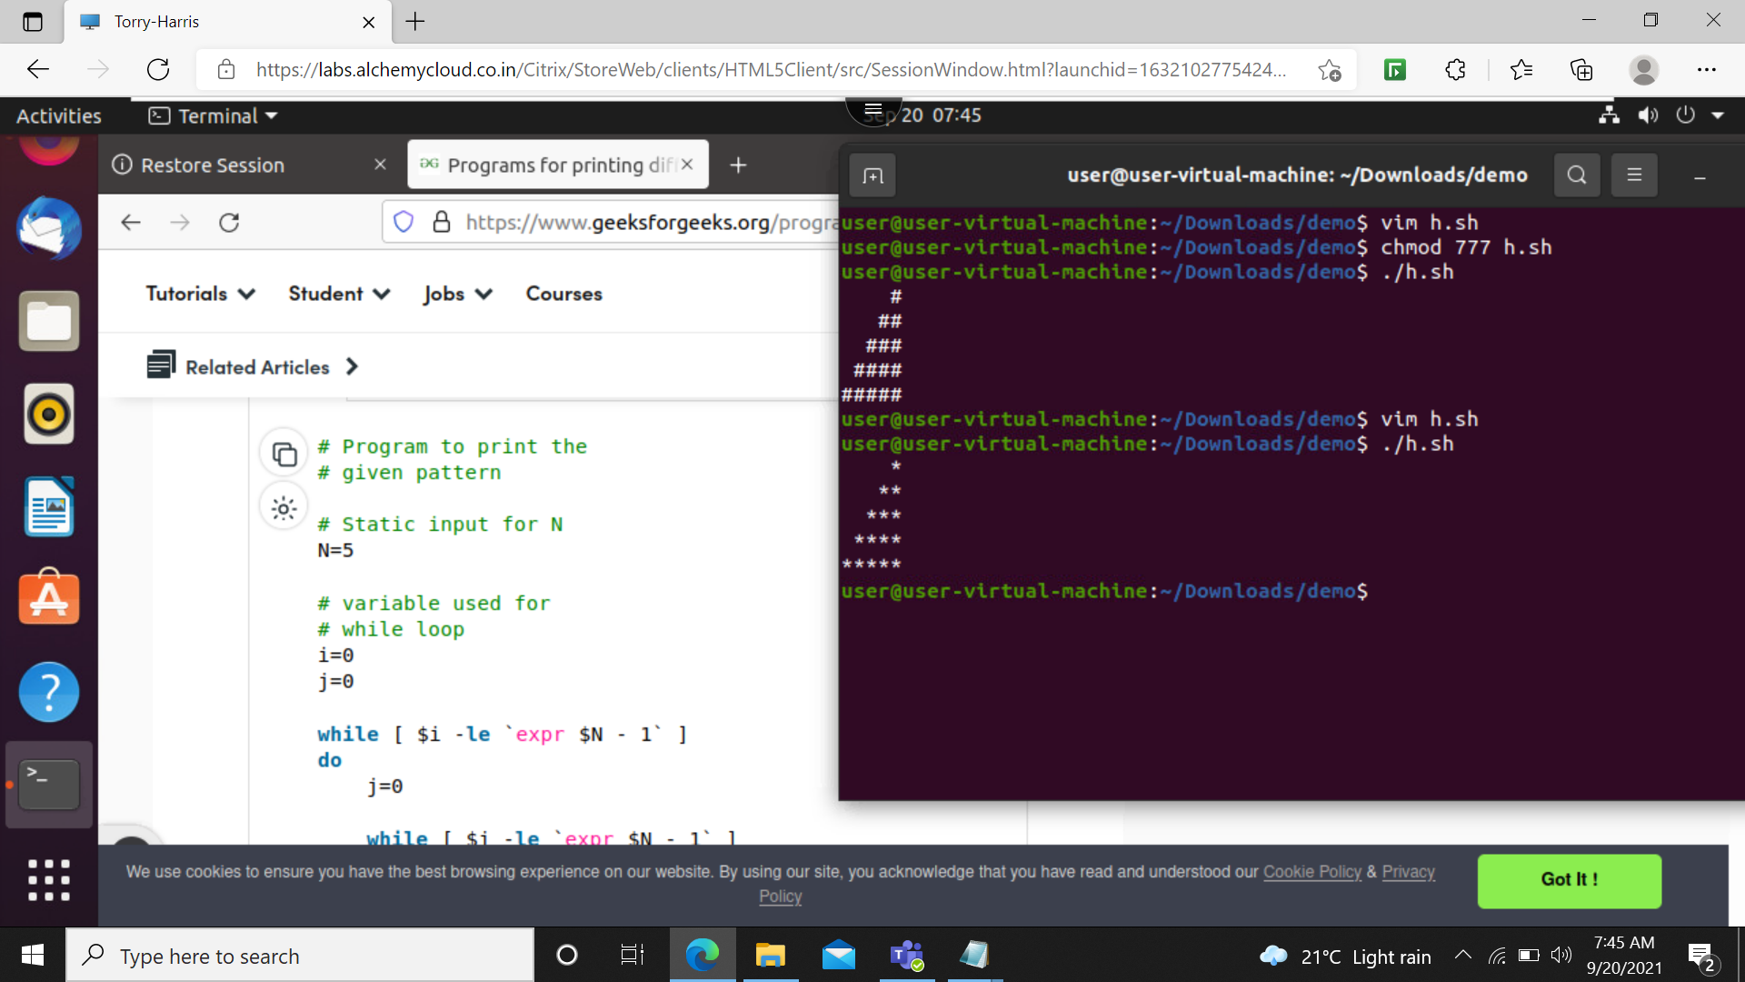

1. program to print multiplication table number
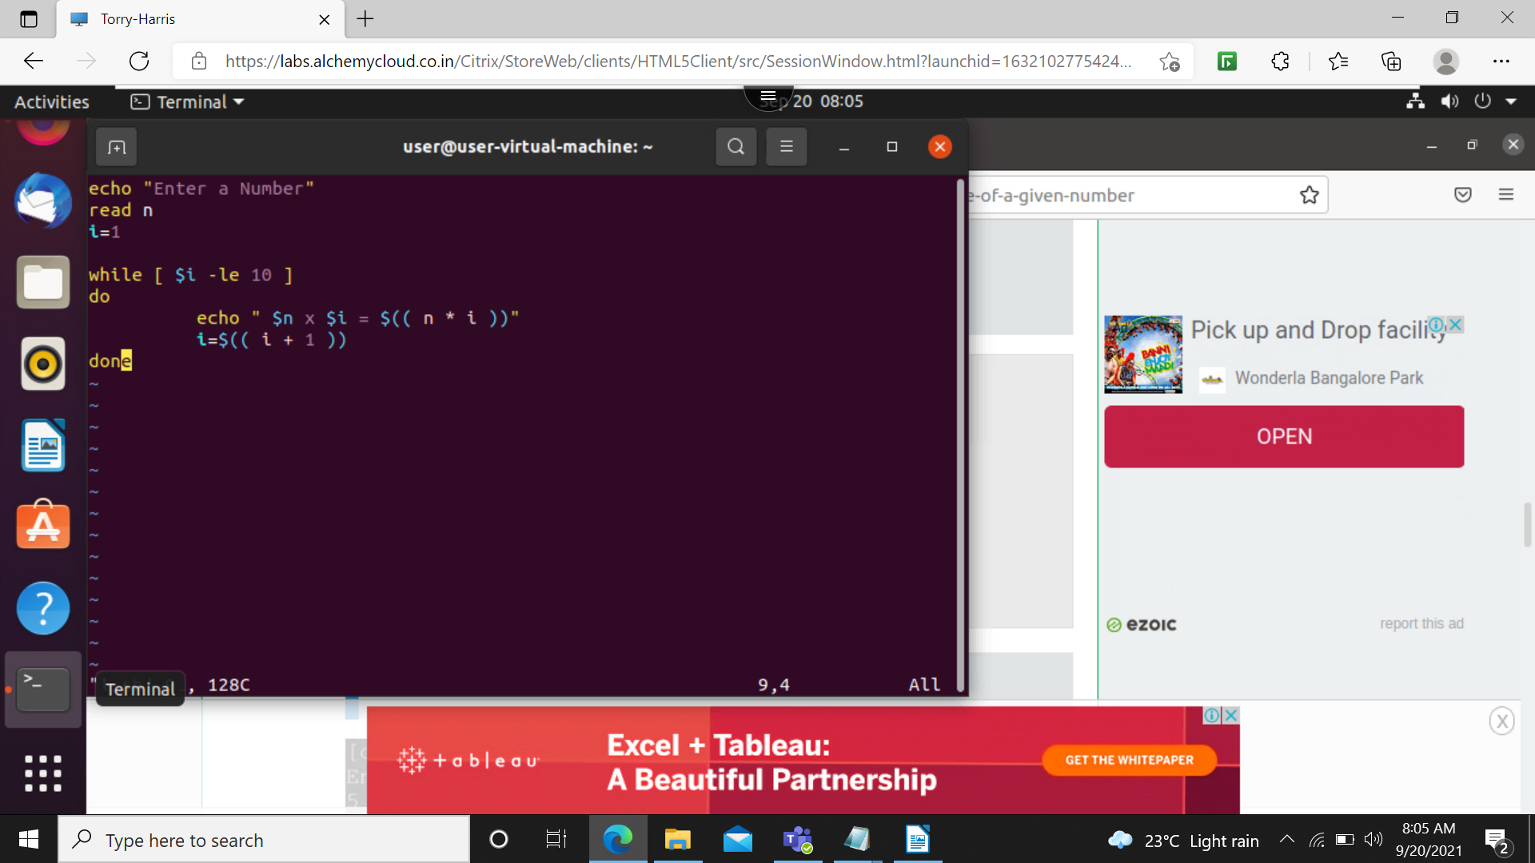

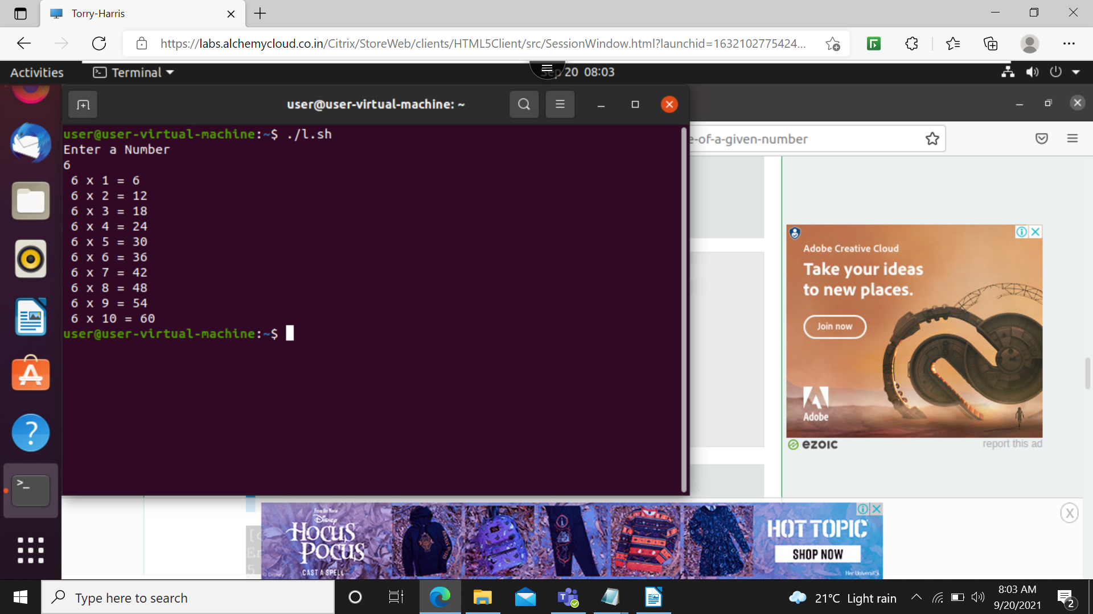

3.
1234
567
89

i=1
while [ $i -le 10 ]
do
echo $i
i=$(($i+1))
done

